

**Software Engineering Department**

**Ort Braude College**

**Capstone Project Phase A**

**Buffet Decoration Ordering System**

**Project team members:** Razi Dallasheh , Abrar Fauzi

**Advisor’s name:**  Zeev Barzilay

**Table of Contents**

**Summary of the project………………………………………………………………………3**

**Abstract…………………………………………………………………………….……………4**

**Introduction…………………………………………..………………………………………5-6**

**Expected Achievements…………………………………………………………………...…7  
  
Criteria of Success…………………………………………………………………………….8**

**Engineering Process………………………………………………………………………….9**

**Methodology and Development Process………………………………………………...10**

**Constraints to be taken care of……………………………………………………………11**

## Requirements…………………………………………………………………………..…12-13

**Diagrams…………………………………………………………………………………...14-20**

**Testing…………………………………………………………………………………...…21-24**

**References…………………………………………………………………………………….25**

**Summary of the Project**

The Buffet Decorations Ordering System is an innovative solution designed to transform the landscape of event planning by addressing existing challenges in the selection and coordination of visual elements. The project stems from a recognized need for a streamlined, user-centric platform that facilitates the customization and ordering of flower bouquets and buffet decorations for events.

The Buffet Decorations Ordering System represents a significant advancement in the event planning industry, providing a comprehensive and user-friendly solution for visual element coordination. By automating and centralizing the process, the project aims to save time, enhance creativity, and foster a memorable and personalized event planning experience.

**Abstract**

In the dynamic realm of event planning, the visual aesthetics play a pivotal role in creating memorable experiences. The Buffet Decoration Project presents an innovative solution to streamline and elevate the process of selecting and ordering buffet decorations and flower bouquets for events. Rooted in the recognition of existing inefficiencies and limitations in the current market offerings, this project aims to revolutionize the way clients conceptualize and execute the visual elements of their events.

At the core of the Buffet Decoration Project lies a sophisticated online platform that empowers users to customize and order flower bouquets while seamlessly coordinating them with matching buffet decorations. By harnessing cutting-edge technologies and user-centered design principles, this platform offers an intuitive interface, comprehensive customization options, and immersive visualizations, thereby enhancing the overall event planning experience.

The project embarks on a multidimensional approach, addressing various facets of the event planning process. It encompasses the creation of a diverse inventory of flower types, colors, and arrangements, as well as an array of buffet decoration options tailored to suit different themes and preferences. Through meticulous attention to detail and meticulous curation, the Buffet Decoration Project endeavours to provide clients with unparalleled flexibility, creativity, and convenience in crafting the ambiance of their events.

Moreover, the Buffet Decoration Project extends beyond the realm of client-facing interactions to encompass robust administrative functionalities. System administrators are equipped with tools for inventory management, order processing, and performance analysis, ensuring seamless operations and optimized user experiences.

As a testament to its commitment to innovation and excellence, the Buffet Decoration Project aligns with the broader industry trends of digital transformation and customization in event planning. By offering a comprehensive and cohesive solution to address the pain points of clients and stakeholders alike, this project seeks to set new standards of excellence in the realm of buffet decorations and flower bouquet ordering for events.

**Introduction**

**Problem Statement:**

In the vibrant world of event planning, creating a visually appealing and harmonious atmosphere through buffet decorations and flower arrangements is a crucial aspect. However, the current process of selecting and ordering such elements for events often lacks efficiency, personalization, and convenience. Clients face challenges in finding tailored solutions that align with their preferences, leading to a gap in the market for a streamlined and user-centric platform.

**What is the problem we want to solve?**

The problem at hand is the cumbersome and time-consuming process of arranging buffet decorations and selecting flower bouquets for events. Clients often struggle with limited options, manual coordination, and a lack of visualization tools, hindering their ability to curate a cohesive and personalized event aesthetic.

**What are the existing solutions today?**

Currently, clients typically engage in a fragmented process, relying on multiple vendors for flower arrangements and buffet decorations. This often involves in-person visits, lengthy consultations, and a lack of visual representation, making it challenging for clients to envision the final outcome. The absence of an integrated platform leads to inefficiencies, misunderstandings, and compromises in the overall event design.

**Proposed Solution:**

Our project aims to address these challenges by introducing an innovative Buffet Decorations Ordering System. This online platform will empower users to seamlessly customize and order flower bouquets while coordinating them with matching buffet decorations, all from the convenience of their devices. By integrating a user-friendly interface, visual representation tools, and a comprehensive range of options, we plan to revolutionize the way clients conceptualize and execute the visual elements of their events.

**What do we plan to do and why will it help solve the problem?**

We propose the development of an intuitive and interactive online platform that facilitates the entire process—from choosing flower types, colors, and arrangements to selecting buffet decorations that complement the chosen theme. By automating and centralizing this process, we aim to save clients valuable time, provide a visual preview of their selections, and offer a diverse range of options for customization. This solution not only simplifies the ordering process but also enhances the overall event planning experience, fostering creativity and personalization.

**Who are the stakeholders and how will the solution help them?**

Stakeholders in this project include event planners, individuals organizing personal events, and businesses hosting corporate functions. Our solution benefits event planners by offering a more efficient and streamlined service, allowing them to focus on the creative aspects of event design. Individuals planning personal events experience convenience and a heightened ability to personalize their celebrations. Businesses benefit from a reliable and visually appealing solution, ensuring a positive and memorable experience for their clients.

**Review of Document Structure:**

Project Overview: Introduces the Buffet Decorations and Flower Bouquet Ordering System, outlining its objectives and features.

Features: Explores the specific functionalities of the system, such as bouquet customization, buffet decorations, and the ordering process.

Technologies: Details the technologies chosen for the project, explaining the rationale behind each selection.

Project Timeline: Outlines the planned phases of the project, from planning and design to testing and deployment.

Budget Estimate: Provides an estimated budget for hosting, domain, and third-party services.

Conclusion: Summarizes the project's goals and how it aligns with the growing trend of online event planning and customization.

**Expected Achievements :**

We have high expectations for our Buffet Decorations Ordering System. We aim to expand the current resources available for event planners and decorators by providing an innovative and user-friendly platform. Our goal is to offer a comprehensive buffet decoration tool that caters to both professionals and enthusiasts, guiding them through the process of creating visually stunning displays that leave a lasting impression on guests.

We expect our system to provide a variety of customization options to cater to the diverse needs and preferences of customers. This includes the ability to choose from various themes, colour schemes, and decoration styles, as well as options for personalised touches such as custom signage or branded elements.

The system will use visual representation tools to assist customers in visualising their selected decorations. This feature will enable customers to visualise their selected decorations in the desired event area, aiding them in making informed choices and guaranteeing satisfaction upon receipt.

Furthermore the system will include robust inventory management capabilities to track available decoration options, quantities, and lead times. This will ensure accurate order fulfilment and prevent overbooking or stockouts, leading to improved efficiency and customer satisfaction.

Additionally ,for decorations that require setup or installation, the system will facilitate coordination between customers and vendors to ensure smooth delivery and setup on the day of the event. This may involve scheduling logistics, communicating setup instructions, and providing real-time updates on order status.

Finally In order to enhance the service, the system will include a feedback and review mechanism where customers can provide input on their ordering experience and the quality of the decorations received. This feedback will be used to identify areas for improvement and drive ongoing enhancements to the system.

**Criteria for Success:**

1. Customer Feedback: Positive feedback from users indicating satisfaction with the customization options, ordering process, and overall user experience.

Retention Rate: A high percentage of repeat customers and referrals, indicating loyalty and satisfaction with the service.

2. Functionality: All planned features, such as bouquet customization, buffet decoration selection, order management, and payment processing, are implemented and functioning correctly.

System Reliability: Minimal system downtime and errors, ensuring a seamless user experience.

3. Performance: System responsiveness meets or exceeds user expectations, with fast loading times for product selection, customization, and checkout.

Scalability: The system can handle increased user traffic and transaction volume without performance degradation.

4. Security: User data is kept secure and protected from unauthorised access or breaches.

Payment Security: Payment transactions are encrypted and processed securely, ensuring customer financial data is safeguarded.

5. Revenue Generation: Achieving targeted revenue goals through successful sales of flower bouquets and buffet decorations.

Market Penetration: Capturing a significant share of the target market for event decoration services.

6. Order Processing Time: Efficient processing of orders with minimal delays, ensuring timely delivery to customers.

Inventory Management: Effective management of inventory levels to prevent stockouts and maintain a diverse selection of products.

7. Adaptability and Growth: The system can adapt to changes in customer preferences, seasonal demand, and market trends.

Future Development: The platform is built with scalability and flexibility in mind, allowing for future updates, enhancements, and expansion into new markets or product lines.

8. Compliance: Full compliance with relevant legal and regulatory requirements, including data protection laws and consumer rights regulations.

9. Customer Support: Prompt and effective resolution of customer inquiries, issues, and complaints, contributing to a positive customer experience.

# **Engineering Process:**

Developing a buffet decoration ordering system involves several steps to ensure its successful implementation.

1. *Research*

To broaden our understanding of the Buffet decoration ordering system, we embarked on comprehensive research to answer critical questions. Firstly, we focused on Identifying the key features and functionalities required for the system:

* User registration and login
* Browse and select decoration options
* Customization options (colors, themes, sizes)
* Pricing and payment processing
* Order tracking and management
* Feedback and rating system
* Virtual preview

To ensure that their needs and requirements are considered during the development process. This user-centric approach will result in a system that is intuitive, user-friendly, and tailored to their requirements.

To confront these requirements and expand our knowledge we conduct interviews, surveys with stakeholders and users to elicit their needs and preferences.

2. *Methodology and Development Process*

For development we chose to go with the Agile methodology which we find to be very fitting to our use case. By working iteratively, we will be able to split our feature delivery into small components with maximum flexibility for changes. We will be splitting out development into:

·       Design the user interface (UI) for both customers and administrators.

·       Implement user registration, login, and authentication functionalities.

·       Build the frontend interface for browsing decoration options, selecting customization preferences, and placing orders.

·       Define the database schema to store user data, decoration options, orders.

·       Develop the backend logic for processing orders, calculating prices, and handling payment transactions securely.

·       Integrate any third-party services or API required for features like payment processing or order tracking.

·       Conduct regular testing throughout the development process to identify and fix any issues.

·       Prepare the system for deployment to the production environment.

·       Set up hosting infrastructure and configure servers, databases, and other necessary components.

·       Deploy the application to the production environment and perform final checks to ensure everything is working correctly.

Throughout the entire process, communication and collaboration with users, as well as regular progress updates, are essential to ensure that the final product meets expectations and delivers value to users.

*3.Constraints to be taken care of*

As we embark on developing our buffet decoration ordering system, it's crucial to acknowledge and carefully consider the constraints we may encounter. These constraints will influence our development approach, but with proper planning and proactive measures, we can effectively navigate them.

Time constraints will be significant. We must establish realistic timelines and milestones, ensuring we allocate enough time for each stage of development, including design, implementation, testing, and deployment. By managing our time closely and following a well-defined plan, we can meet project deadlines and deliver the system on schedule.

Technical constraints are another critical aspect. We need to assess the limitations and capabilities of our chosen technology stack, development tools, and infrastructure. Regularly monitoring emerging technologies and industry best practices will allow us to adapt and enhance the functionality and performance of our system.

Compliance and regulatory constraints cannot be overlooked. We must adhere to relevant legal requirements, data protection regulations, and industry standards. Integrating privacy controls, security measures, and compliance protocols into our development process is essential to safeguard user data appropriately.

User requirements and expectations should guide our development efforts. Engaging with users, conducting research, and gathering feedback throughout the process will ensure that our system meets their needs and preferences. Emphasising user-centric design and incorporating iterative feedback loops will lead to a product that resonates with our users.

## Requirements

**Functional:**

|  |  |
| --- | --- |
| **1** | **Users should be able to create an account by providing their name, email address, contact information, and password.** |
| **2** | **Users should be able to manage their profiles, including updating personal information, notification preferences and change the password.** |
| **3** | **Registered users should be able to log in to their accounts using their email address and password.** |
| **4** | **Users should be able to filter decorations based on criteria such as price range, decoration category, and decoration theme.** |
| **5** | **The website should display a catalogue of available buffet decorations.** |
| **6** | **Each decoration listing should include detailed information such as description, price, available quantity, and images.** |
| **7** | **Users should be able to add decorations to their shopping cart.** |
| **8** | **Users should be able to view and edit the contents of their shopping cart before proceeding to checkout.** |
| **9** | **The system should send an order confirmation email or message to the user after successfully placing an order.** |
| **10** | **Users should be able to view their order history and track the status of their orders.** |
| **11** | **The website should support secure payment processing through various payment methods (credit card, PayPal).** |
| **12** | **The system should handle payment verification and notify users of successful or failed transactions.** |
| **13** | **Users should receive email notifications for important events such as order confirmation, order status updates, and promotions.** |
| **14** | **Users should be able to upload a photo of their event space or choose from a set of templates representing different types of background.** |
| **15** | **Users should be able to place selected decorations onto the background image.** |
| **16** | **Users should be able to view their live preview decoration and update the virtual preview in real-time.** |
| **17** | **Admins should have access to an admin panel to manage products, orders, and user accounts.** |
| **18** | **Admins should be able to add, edit, and delete decorations from the product catalogue.** |

**Non-functional:**

|  |  |
| --- | --- |
| **1** | The system should respond to user inputs and actions within 5 seconds under normal load conditions. |
| **2** | The system should handle at least 50 transactions simultaneously during peak usage times. |
| **3** | The interface should be intuitive and easy to navigate for all user types, including those with no technical expertise. |
| **4** | The system should be available 99.9% of the time, ensuring minimal downtime. |
| **5** | In the event of a system crash, recovery should be possible within 5 minutes with minimal data loss. |
| **6** | The system should scale to handle increases in user traffic and data volume without degradation of performance. |
| **7** | Efficient use of server and network resources should be maintained as the system scales. |
| **8** | The system should be designed in a modular fashion to facilitate easy maintenance and upgrades. |
| **9** | Code should adhere to industry-standard best practices and guidelines to ensure it is clean, well-documented, and easy to maintain. |
| **10** | The system should be capable of integrating seamlessly with external systems such as payment gateways or email service providers. |
| **11** | Compliance with relevant industry standards for e-commerce and online security. |
| **12** | The system should be deployable across various operating systems and devices without significant modifications. |

**Diagrams:**

Use Case Diagram:

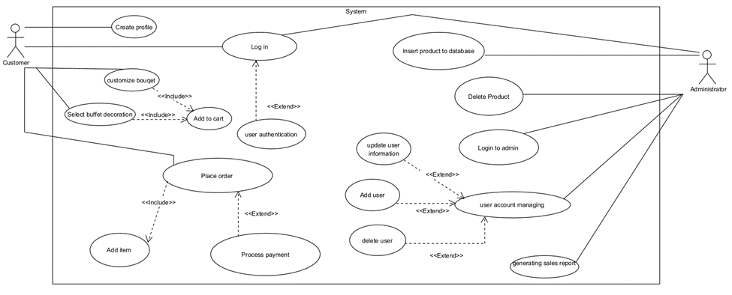

**Customer's Interactions:**

·       Create Profile: Customers can create a profile on the platform. This is the entry point into the system for new users.

·       Log in: Existing customers log into the system to access its features.

·       Customize Bouquet: After logging in, customers can customize bouquets. This includes selecting the type of flowers, colors, and arrangements.

·       Select Buffet Decoration: Customers can also select and customize buffet decorations, choosing themes and additional items.

·       Add to Cart: Both the customized bouquet and the selected buffet decorations can be added to the shopping cart.

·       Place Order: After adding items to the cart, the customer can place an order. This likely involves providing additional information like shipping details and confirming the order.

·       Add Item: The customer may add more items to the cart. This use case is included in the Place Order process, indicating that it is a part of the ordering sequence.

·       Process Payment: The final step for the customer is to process the payment for the order. This use case extends the Place Order use case, showing that it is an additional action that can happen during the order placement.

**Administrator's Interactions:**

·       Insert Product to Database: The administrator can add new products, such as new flower types or buffet decorations, to the system's database.

·       Delete Product: The administrator has the authority to remove products from the database.

·       Login to Admin: The administrator logs into a special admin area to manage the platform.

·       User Account Managing: Within the admin area, the administrator can manage user accounts, which includes updating user information, adding new users, and deleting users.

·       Generating Sales Report: The administrator can generate sales reports to track the performance of the platform.

**System's Responsibilities:**

·       User Authentication: This is a system function that verifies user credentials during login. It extends both the customer login and admin login, meaning it's a shared functionality.

·       Update User Information: This is a system function related to maintaining the current and accurate data of user profiles.

·       Add User/Delete User: These are admin-level functionalities allowing the system to handle the creation and removal of user accounts.

**Activity Diagram:**

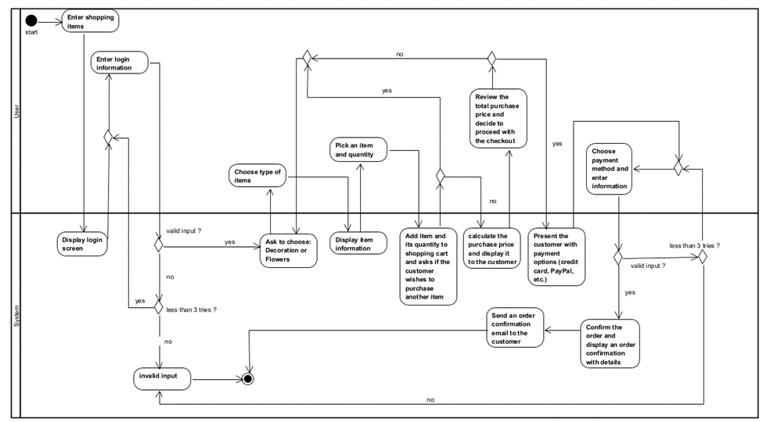

**User Activities:**

·       Enter Shopping Items: The process begins with the user starting the shopping procedure.

·       Enter login information: The user is prompted to log in to access the system.

·       Choose type of items: After a successful login, the user selects the type of items they are interested in, such as decorations or flowers.

·       Pick an item and quantity: The user selects a specific item and the quantity they wish to purchase.

·       Review the total purchase price and decide to proceed with checkout: The user reviews the total cost of the items in their cart and decides whether to proceed to checkout.

·       Choose payment method and enter information: If proceeding to checkout, the user selects a payment method and provides the necessary details.

·       Confirm order and display an order confirmation with details: The system finalizes the order and provides the user with an order confirmation and details.

**System Activities:**

·       Display login screen: The system presents the login interface to the user.

·       Display item information: When an item and its quantity are selected, the system displays relevant details to the user.

·       Add item and its quantity to shopping cart: The system updates the shopping cart with the user's selections.

·       Calculate the purchase price and display it to the customer: The system calculates the total price of the items in the cart.

·       Present the customer with payment options: The system offers various payment methods to the customer.

·       Send an order confirmation email to the customer: After order confirmation, the system sends an email to the customer with the order details.

**Error Handling:**

The system allows for a certain number of invalid inputs (less than three tries) when entering login information or payment details. If the input is invalid beyond the allowed number of attempts, the process is terminated, as shown by the end event labeled "Invalid input."

**Looping:**

After adding an item to the cart, the user is asked if they wish to purchase another item, allowing for multiple items to be added to the cart before proceeding to checkout.

During the payment information step, if the input is invalid, the user is prompted to re-enter the information, assuming they are within the allowable number of tries.

**Class Diagram:**

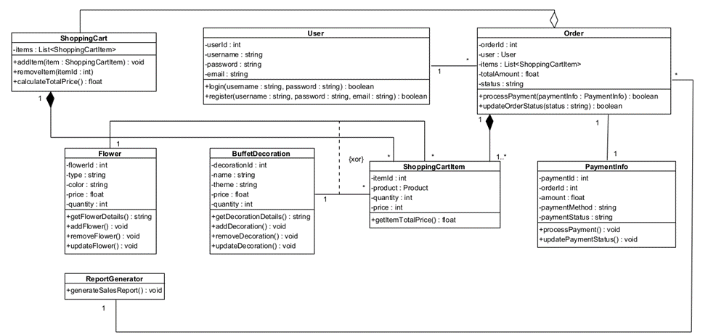

**Classes Explained :**

Classes and Attributes:

1.      User:

·       Attributes: userId, username, password, email.

·       Methods: login, register.

2.      Order:

·       Attributes: orderId, user, items, totalAmount, status.

·       Methods: processPayment, updateOrderStatus.

·       Associations: Contains a User and multiple ShoppingCartItem objects; also linked to a PaymentInfo object.

3.      ShoppingCart:

·       Attributes: items (a list of ShoppingCartItem).

·       Methods: addItem, removeItem, calculateTotalPrice.

4.      ShoppingCartItem:

·       Attributes: itemId, product, quantity, price.

·       Methods: getItemTotalPrice.

·       Associations: Contains a Product (could be a Flower or BuffetDecoration).

5.      Flower (extends Product):

·       Attributes: flowerId, type, color, price, quantity.

·       Methods: getFlowerDetails, addFlower, removeFlower, updateFlower.

6.      BuffetDecoration (extends Product):

·       Attributes: decorationId, name, theme, price, quantity.

·       Methods: getDecorationDetails, addDecoration, removeDecoration, updateDecoration.

7.      PaymentInfo:

·       Attributes: paymentId, orderId, amount, paymentMethod, paymentStatus.

·       Methods: processPayment, updatePaymentStatus.

8.      ReportGenerator:

·       Methods: generateSalesReport.

**Relationships:**

·       Association: This is represented by a solid line connecting classes that communicate with each other. For example, an Order is associated with the User who made it.

·       Aggregation: Depicted by a hollow diamond, it represents a whole-part relationship but does not imply ownership. For example, ShoppingCart contains ShoppingCartItem objects, but their lifecycle is not necessarily tied to that of the ShoppingCart.

·       Composition: Shown by a filled diamond, it's a strong form of aggregation that implies ownership and coincident lifecycle of the part by the whole. An Order is composed of one or more ShoppingCartItem objects, which suggests that if an Order is deleted, the associated ShoppingCartItem objects would also cease to exist.

·       Inheritance: Represented by a line with a hollow arrowhead, it shows a generalization/specialization relationship where Flower and BuffetDecoration are specialized types of a Product.

·       Multiplicity: Indicated by numbers like "1" or "1..*", it defines how many instances of a class can be associated with one instance of another class. For instance, a ShoppingCart contains one or more ShoppingCartItem objects.

Explanation of Functionality:

The system allows a User to create a profile and log in. Once logged in, they can use a ShoppingCart to select items (Flower or BuffetDecoration), each represented by a ShoppingCartItem. They can then place an Order, which aggregates these items, includes PaymentInfo, and calculates the total amount. Orders can have their payment processed and status updated. The system also includes a ReportGenerator class, which can generate sales reports, likely for administrative purposes.

The diagram provides a static view of the system, defining how the various objects relate to and interact with each other, providing a blueprint for the system's design and implementation.

**Testing**

To ensure functionality, reliability, and security of our Buffet decoration ordering system

we will be designing developing and testing our modules:

·       Write unit tests to verify the functionality of individual components and modules.

·       Conduct integration testing to ensure seamless communication between frontend and backend systems.

***Login and user registration***

|  |  |  |  |
| --- | --- | --- | --- |
| **Test#** | **Description** | **Expected Result** | **Pass/Fail** |
| **1** | Start system | Main system page opened | Pass |
| **2** | Enter the correct user name and password. then click login button | Accept userName and password and display | Pass |
| **3** | Enter invalid Username or  Password and click login button | Error message “Login Failed” | Pass |
| **4** | Signup new user  and click Signup button | Appear login form | Pass |
| **5** | Adding invalid details when registering a new user entering unequal password or invalid Email address | Display “Enter valid Email Address and passwords should be the same. | Pass |
| **6** | Resetting password by using login form Clicking Forgot Password button | Appear resetting password form | Pass |
| **7** | Resetting passwordbyEntering new password and confirmation code Clicking Reset Password button | Appear login form | Pass |

***User main actions***

|  |  |  |  |
| --- | --- | --- | --- |
| ***Test#*** | ***Description*** | ***Expected Result*** | ***Pass/Fail*** |
| ***1*** | *Enter the correct username and password. then click login button* | *Appear main page* | *Pass* |
| ***2*** | *Open options Menu by Clicking Menu button* | *Appear Menu Options* | *Pass* |
| ***3*** | *Open Main page Option by pressing on Main button* | *Appear main page* | *Pass* |
| ***4*** | *Open search page by pressing on search button* | *Appear search page* | *Pass* |
| ***5*** | *Searching decoration products based on criteria* | *Appear suitable  products page* | *Pass* |
| ***6*** | *View a product details by pressing on details button* | *Appear product’s details page* | *Pass* |
| ***7*** | *Adding decoration to shopping cart by pressing on cart button* | *Appear shopping cart page* | *Pass* |
| ***8*** | *Enter the old password and the new password. then click update password* | *Password updated* | *Pass* |
| *9* | *Enter order history by pressing order button* | *Appear order history page* | *pass* |
| ***10*** | *Adding background to virtual preview* | *Appear virtual preview page* | *pass* |

***Admin main Actions***

|  |  |  |  |
| --- | --- | --- | --- |
| **Test#** | **Description** | **Expected Result** | **Pass/Fail** |
| **1** | Manage user accounts by using update user details page Clicking search button | found specific user | Pass |
| **2** | Manage user accounts by using update user details page Clicking delete button | Delete specific user | Pass |
| **3** | Manage user accounts by using update user details page Clicking update button | update specific user detail | Pass |
| **4** | Manage user accounts by using update user details page Clicking add button | Add new user | Pass |
| **5** | See all users details by clicking manage user account button | Appear manage user account page | Pass |
| **6** | Enter the correct user name and password. then click login button | Appear Admin main application page | Pass |
| **7** | Enter the invalid Username and Password and click login button | Error message “Login Failed” | Pass |
| **8** | Update Admin details by clicking Security info button | Appear update user details page | Pass |
| **9** | Enter Old Password and New Password and click update Password button | Password updated | Pass |
| **10** | Manage products by using update product details and click add button | Adding new product | Pass |
| **11** | Manage products by using update product details and click delete button | Deleting old product | Pass |
| **12** | Manage products by using update product details and click edit button | Edit a product’s details | Pass |
| **13** | Generate reports by clicking generate reports button | Appear generate reports page | Pass |
| 14 | Fill correct report date and click search button | Report found | pass |
| 15 | Fill incorrect report date and click search button | Error message “Report not found” | pass |
| 16 | Generate new report by clicking generate report button | new report generated | pass |

**References**

1.  Fowler, M. (2004). UML Distilled: A Brief Guide to the Standard Object Modeling Language (3rd ed.). Addison-Wesley Professional.

2.  Chung, L., & do Prado Leite, J. C. S. (2009). On non-functional requirements in software engineering. In Conceptual modelling: Foundations and applications (pp. 363-379). Springer, Berlin, Heidelberg.

3.  Nielsen, J. (1994). Usability Engineering. Academic Press.

4.  Kerzner, H. (2017). Project management: A systems approach to planning, scheduling, and controlling (12th ed.). John Wiley & Sons.

5.  Sommerville, I. (2011). Software Engineering (9th ed.). Addison-Wesley.

*6.*      Séraphin, H., & Jarraud, S. (2021). The future of events in a post-pandemic world. *Frontiers in Event Management*

7.      Orefice, C. (2018). Designing for events – a new perspective on event design. *International Journal of Event and Festival Management*, 9(1), 20-33.

*8.*      *Drying of flowers: A money-spinning aspect of floriculture industry." (2021).* Phytojournal*, 10(2), 643. Retrieved from:* [*https://www.phytojournal.com/archives/2021/vol10issue2S/PartA/S-10-1-124-643.pdf*](https://www.phytojournal.com/archives/2021/vol10issue2S/PartA/S-10-1-124-643.pdf)